|  |  |
| --- | --- |
| **Data Science and Analytics (IT3080)**  **B.Sc (Hons) in IT (IT Specialization) Year 3** |  |

**Lab Sheet 08**

# Data Visualization

## Power BI Desktop – Data Visualization

In this section, you create a professional report for the benefit of you and your entire team. At the end of this section, you will build a report like the one shown in the screenshot below.

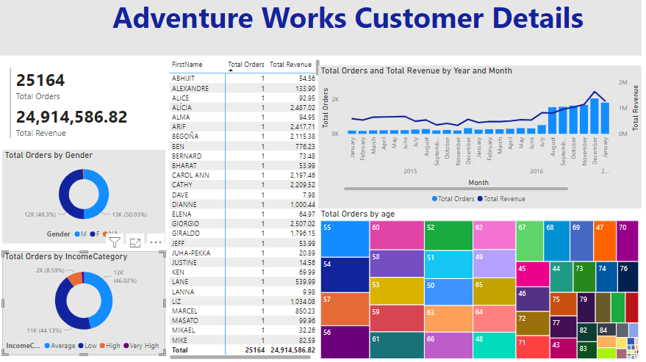

Now let’s get started, we will pick up where we left off at the end of Lab sheet 7. Let’s add a report title first.

1. From the ribbon, click **Home** and then click **Text box**. Notice a text box visual is added.
2. **Resize** the visual as needed.
3. Enter **Adventure Works Customer Details** in the text box.
4. Highlight **Adventure Works Customer Details** to format the text.
5. Select **Segoe (Bold)** as the **font**.
6. Select **36** as the **font size**.
7. Resize the text box as needed.



1. To add a background color, select the **title**. Then under **Format** click on the **Effects**. Select a background color.

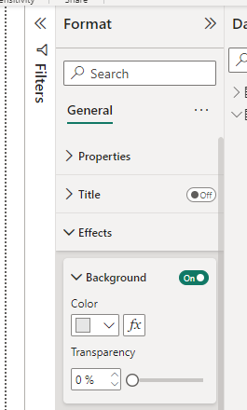

Add the tiles gained from the previous lab sheet. Your report should look as shown in the figure above. Now let’s finish up by saving the file.

# 

# Activity 01: Load Sales data set to Power BI and create the following data visualizations.

1. Create the following data visualization charts
   1. Display the sales by country using a column chart
      1. Change the color of the data columns to purple.
      2. Draw a line to mark the average sales.
   2. **Sales and Profit by month**
      1. Display sales and profit for each month in a stacked area chart
      2. Sort the values in the ascending order
      3. Display the data in the order of months
      4. Display the records only for the first 4 months of the year
      5. Display maximum sales and maximum profit of each month in the graph
   3. **Sales by product**
      1. Display the sales by product in a funnel
      2. Display the records in the ascending order of sales
      3. Display the average sales records by product
      4. Display the products with average sales records more than 165000
      5. Arrange the records in ascending order and give separate colors for each product
   4. **Sales and profit by segment**
      1. Display sales and profit by segment in a bar graph
      2. Mark the minimum profit level in the graph and display its value
      3. Display the minimum sales level and its value in another color
2. Create all the charts in the same page. Add an appropriate title.

**Activity 02**

Your manager wants to see a report on your latest sales figures. They've requested an executive summary of:

* Which month and year had the most profit?
* Where is the company seeing the most success (by region)?
* Which product and segment should the company continue to invest in?

Build a report with a title, three visuals, and a slicer